1. Exception is a class/interface/abstract class/other?

1. **Class**
2. Interface
3. Abstract class
4. Other

2. Which of these class is highest in hierarchy in java

1. java.lang.Exception
2. java.lang.Error
3. java.lang.Throwable
4. **java.lang.Object**

3. What keyword is used to explicitly raise a exception?

1. catch
2. **throw**
3. throws
4. raise

4. Exception and Error are direct subclasses of?

1. BaseException
2. **Throwable**
3. Object
4. RuntimeException

5. Which is valid about java.lang.Exceptions?

1. The class Exception and all its subclasses that are not also subclasses of RuntimeException are checked exceptions
2. The class Error and all its subclasses are unchecked exceptions
3. The class RuntimeException and all its subclasses are unchecked exceptions
4. **All**

6. What will be output of following program –

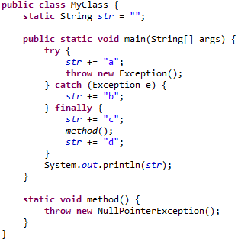

1. abc
2. abcd
3. **runtime exception**
4. compile timeError

7. Which of the following is false as far as type 4 driver is concern?

1. Type 4 driver is “native protocol, pure java” driver
2. Type 4 drivers are 100% Java compatible
3. Type 4 drivers uses Socket class to connect to the database
4. **Type 4 drivers cannot be used with Netscape**

8. Which of the following methods are needed for loading a database driver in JDBC?

1. registerDriver() method
2. Class.forName()
3. **Both A and B**
4. getConnection()

9. When the message "No Suitable Driver" occurs?

1. When the driver is not registered by Class.forname() method
2. When the user name, password and the database does not match
3. **When the JDBC database URL passed is not constructed properly**
4. When the type 4 driver is used

10. JDBC facilitates to store the Java objects by using which of the methods of   
 PreparedStatement

1. setObject ()

2. setBlob()

3. setClob()

1. 1, 2
2. **1,2,3**
3. 1,3
4. 2,3

11. The JDBC-ODBC Bridge supports multiple concurrent open statements per connection?

1. True
2. **False**

12**.** Which of these modifiers can be used for a variable so that it can be accessed from any thread or parts of a program?

1. transient
2. **volatile**
3. global
4. No modifier is needed

13. To determine the width and height of an application, which of the following method is used?

1. getWidthHeight()
2. setWidthHeight()
3. **getSize()**
4. setHeightWidth()

14. The implementation-specific properties like ascent, descent of a font object is implemented by

1. Font class
2. Regular class
3. **FontMetrics class**
4. Graphics class

15. What tags are mandatory when creating HTML to display an applet?

1. name, height, width
2. code, name
3. codebase, height, width
4. **code, height, width**

16. All Applets must import java.applet and java.awt.

1. **True**
2. False

17. What are the Applet’s life cycle methods?

1. init(), start() and stop()
2. **init(), start(), paint(). stop() and destroy()**
3. init(), start() and destroy()
4. init(), start() and stop()

18. The means by which the browser and the applet communicate is

1. AppletSkeleton interface
2. AppletApplication interface
3. **AppletStub interface**
4. AppletWindow interface

19. In the Java API, classes are grouped into ___________.

1. Folder
2. **Package**
3. Library
4. War

20. Which of the following is not a class of reflection API?

1. **Class**
2. Field
3. Method
4. Constructor